Upload a document which explains what you have done to tackle the problem of littering at your school. Include photos, an explanation and what outcomes you have achieved

What have we done?

- We have taken part in the Keep Britain Tidy Great British Spring Clean – both in school and also off site at a local Councillor request

- We did an eco-code for our notice board

- We have made a video about littering and had it tweeted out. (already put on Tasks elsewhere)

- We did a Litter Audit so school can see what is worst rubbish dropped

- We have spread the word about the importance of keeping our school clean and other students not part of the eco team (yet) are wanting to join in –see email copied below

- We have had a brain storming session and come up with lots of ideas. The Bag for a Bag idea has already been agreed by our Head of School and is happening in July

- We have formed a sub team just for Litter

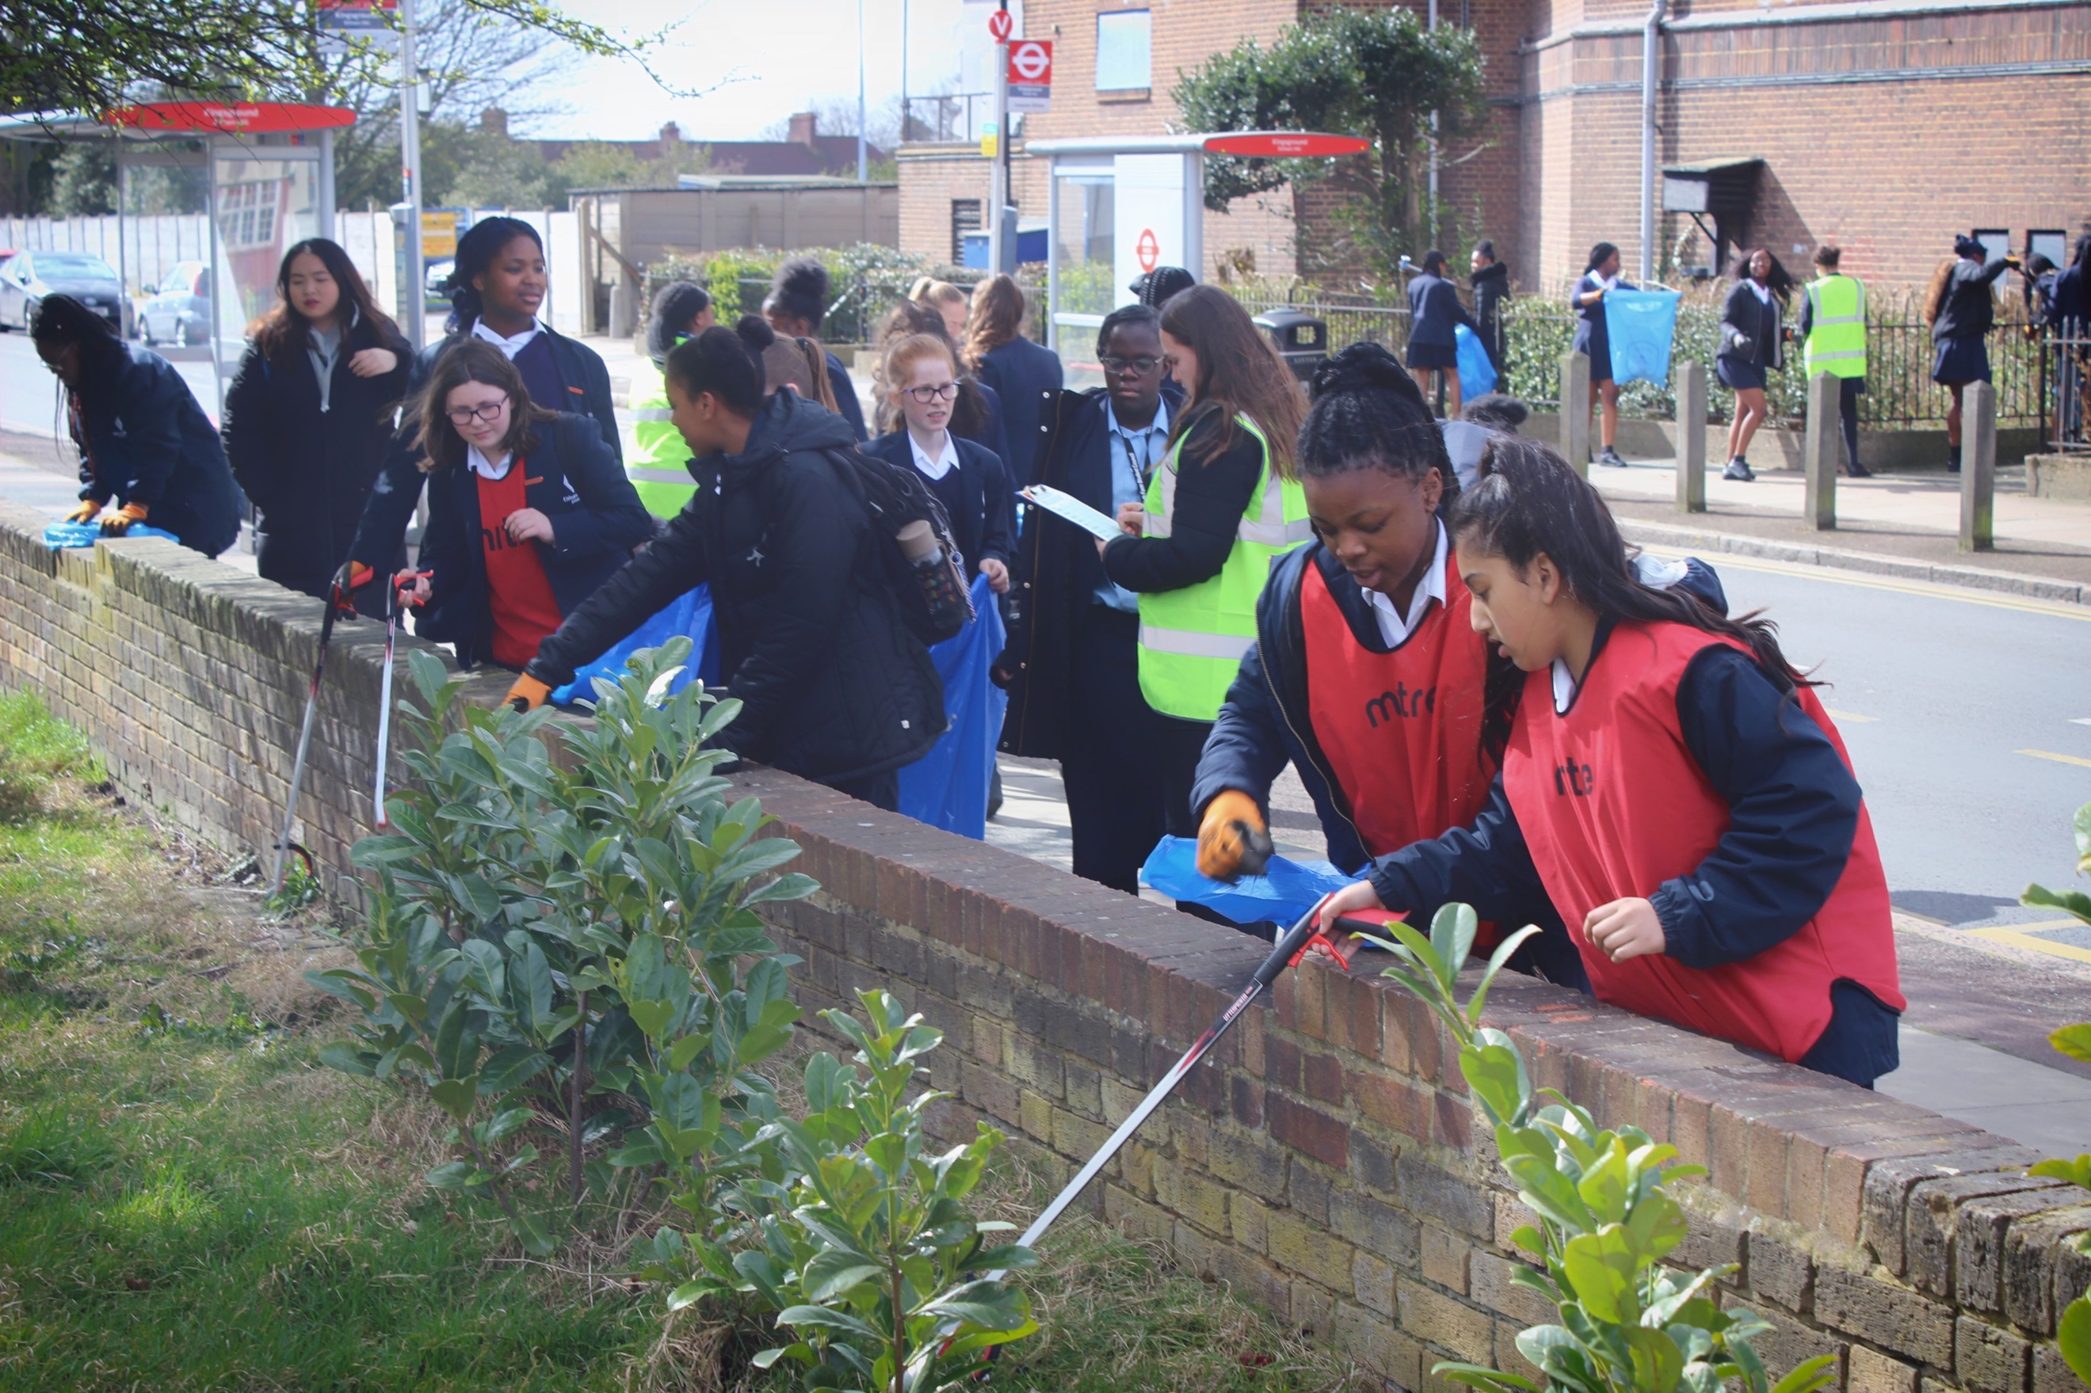

- 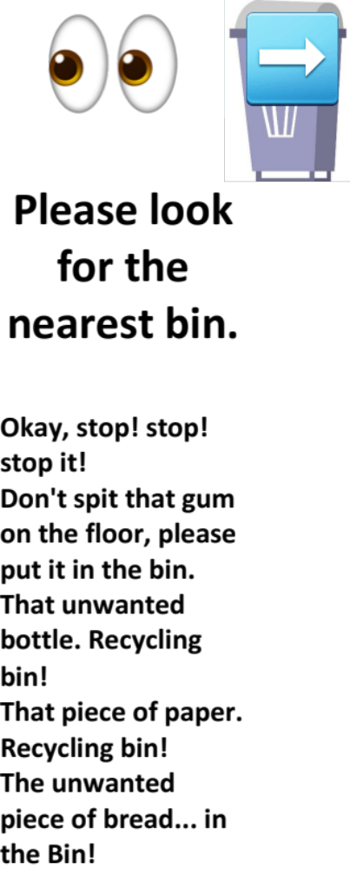
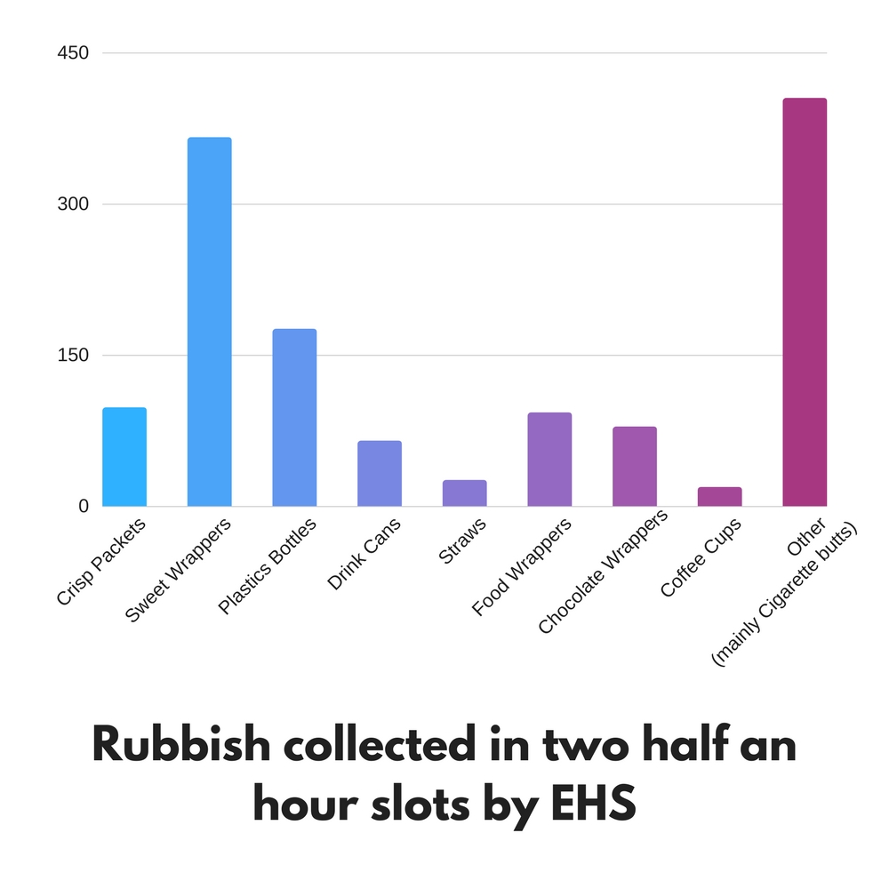

Dear all,

The following students have kindly volunteered to participate in picking up litter in their spare time to help keep the school clean:

Amber Pledge 9A
Franqui Osbourne 9M
Tallulah Boronat 9M
Morgen McCameron 9M
Adepeju Alakija 9M

I will meet with the girls to discuss what days they can kindly help around the school and where to find the equipment to use and return (and to possibly join the Eco team).

I would like to give out certificates once they have completed their task at the end of term.

Kind regards,

Benita

